1). The main screen shows a curated selection of recipes

/recipes

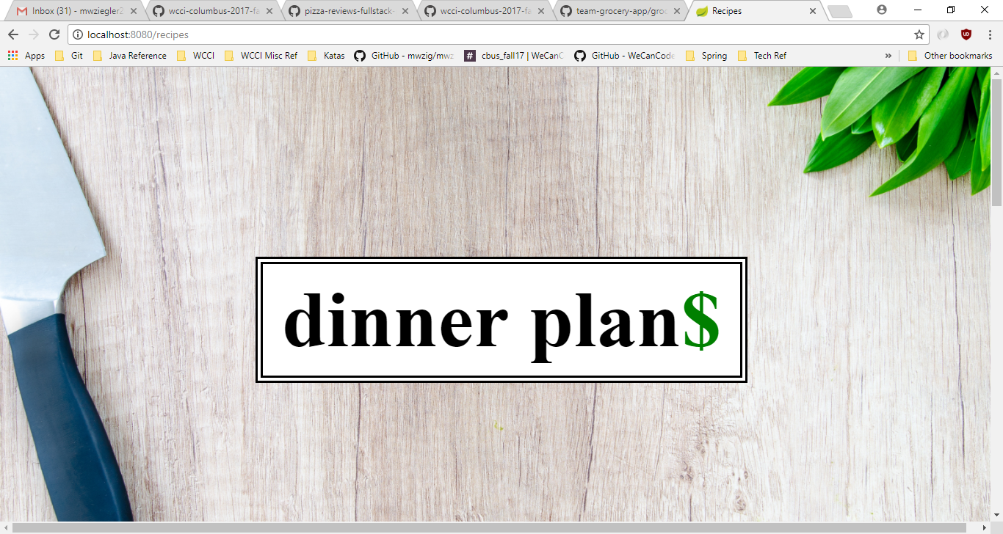

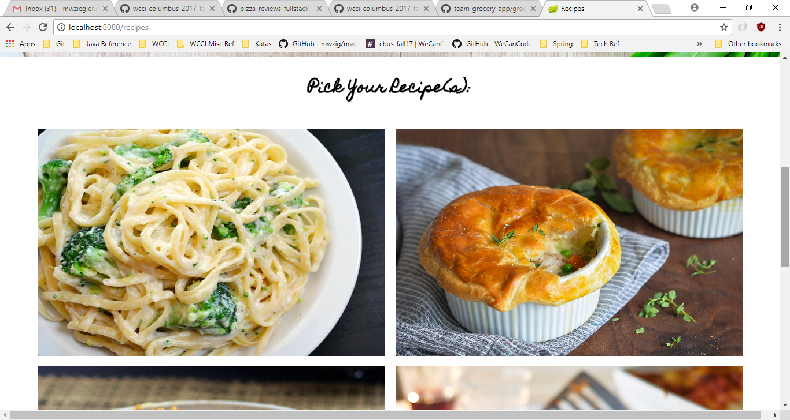

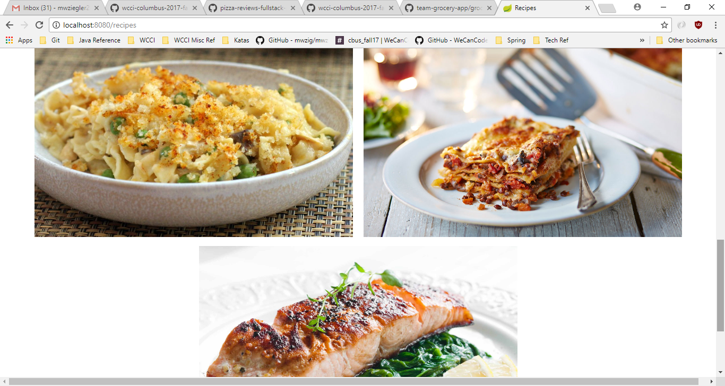

2). After selecting a recipe you see the details

/recipe

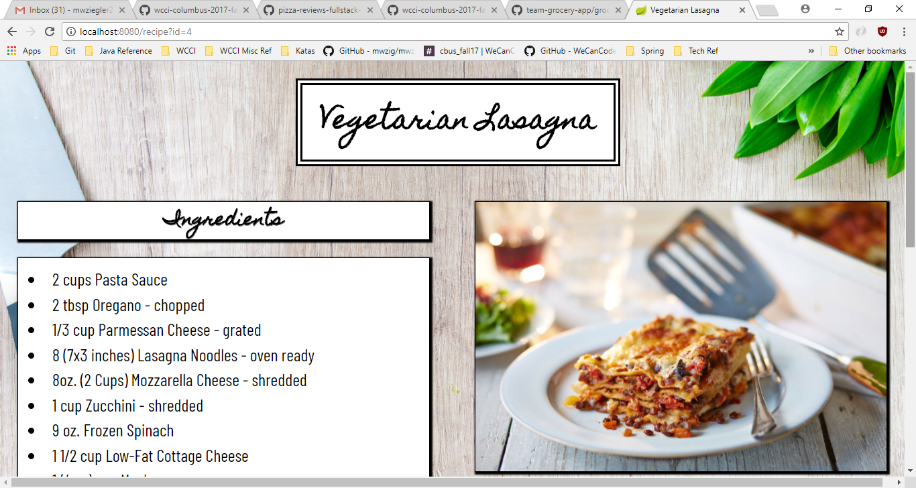

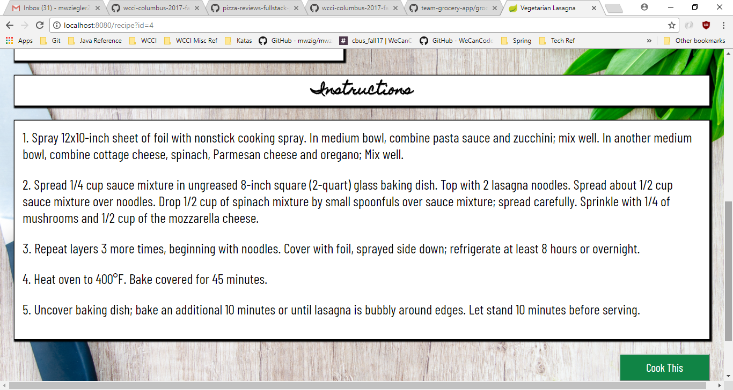

3). After looking at the recipe, you click the “cook this” button to see an ingredient list so you can see what you need to build your grocery list

http://localhost:8080/ingredients

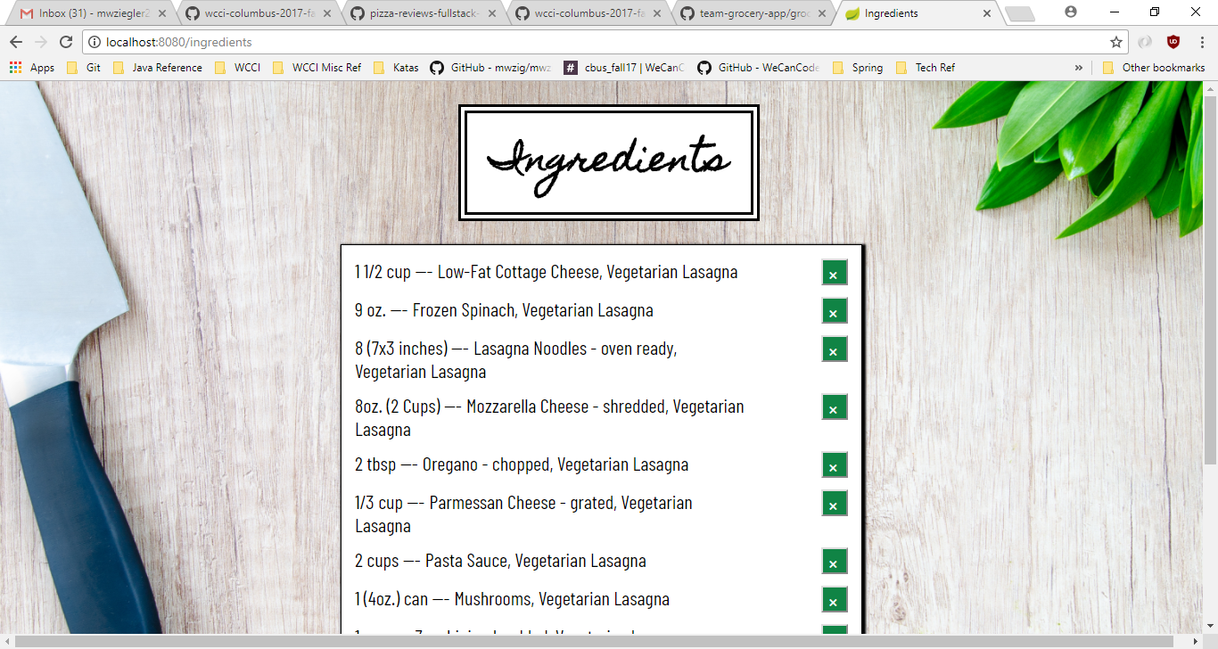

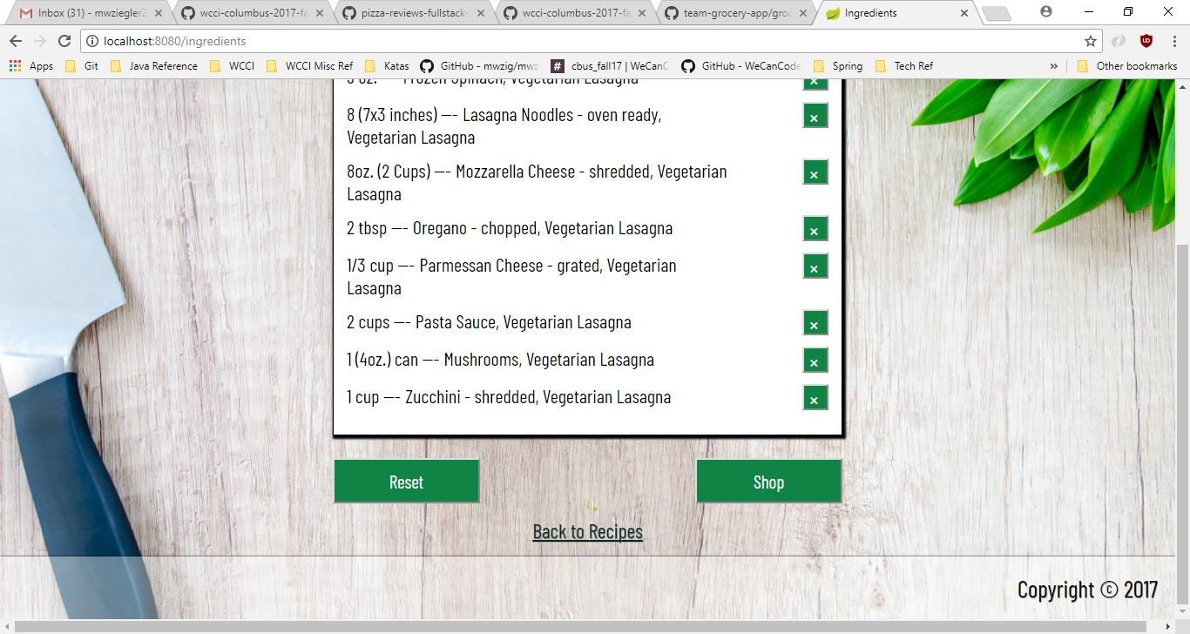

After “x”-ing out unnecessary ingredients (you already have them on hand)

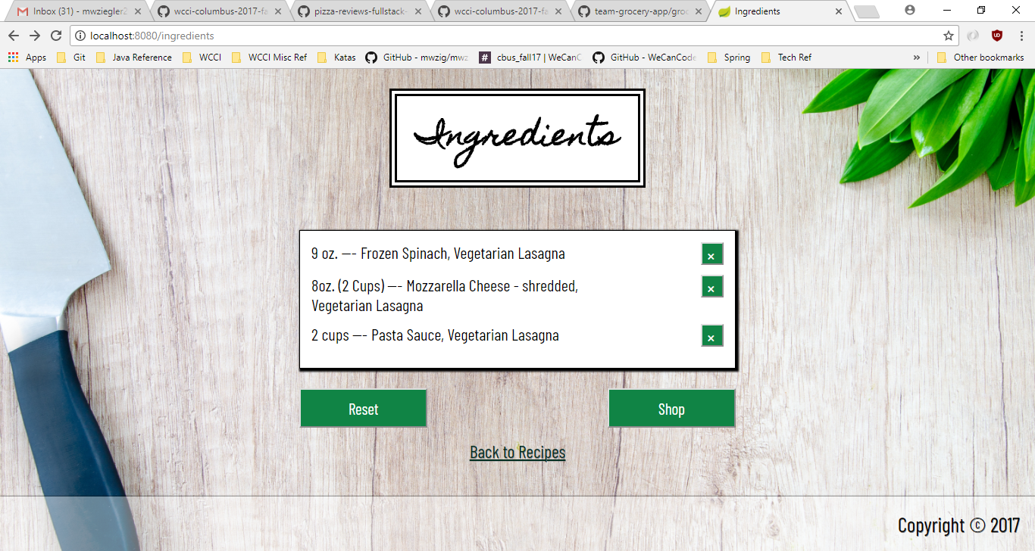

4). (after clicking shop “button” after selecting which ingredients you need, you see 3 options for each ingredient and you can select your choices)

<http://localhost:8080/store-items>

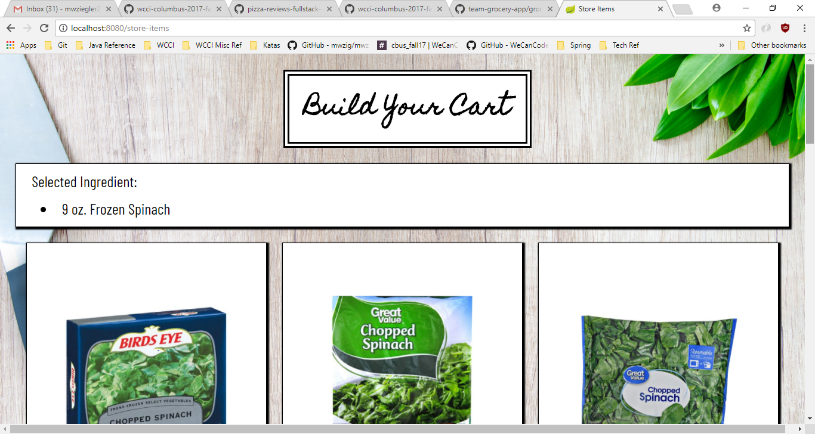

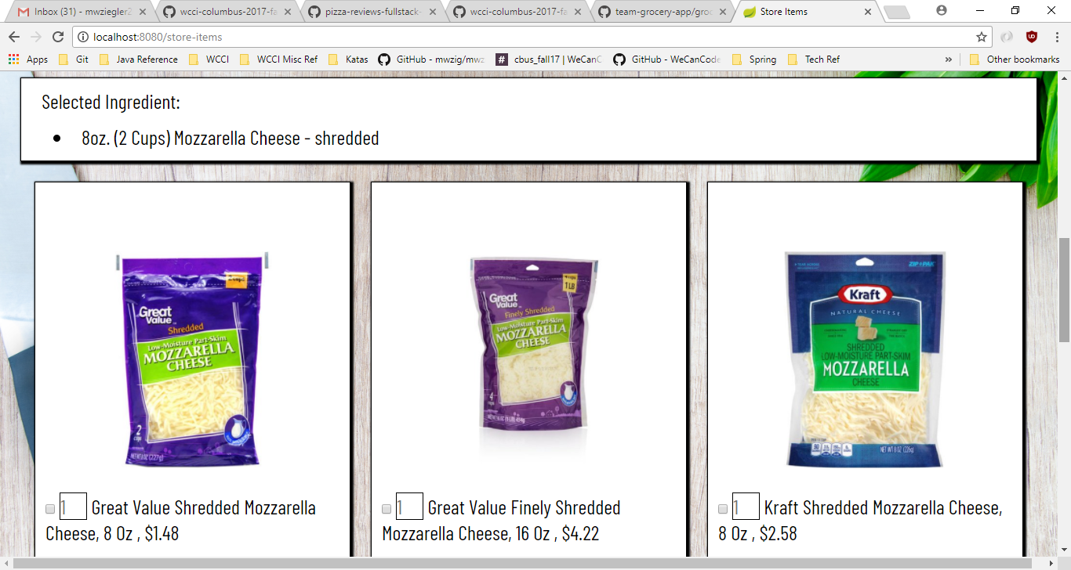

5). After clicking “submit button” you see your grocery list with a total cost

/grocery-list

